PRESS RELEASE

Freudenberg to return to Wire Düsseldorf in 2026

Weinheim, Germany, February 12, 2026. Freudenberg Performance Materials (Freudenberg) is returning to the Wire trade fair in Düsseldorf, Germany, after a gap of several years. The experts from the world's leading supplier of technical textiles are looking forward to presenting their comprehensive range of high-performance tapes for power, data, and specialty cables to visitors at the trade fair and discussing solutions with them at stand D19 in Hall 13 from April 13-17.

Freudenberg will showcase its high-performance cable tapes for all kinds of applications, including power, data, fiber optic, telecom, and special cables. Its cable tape product range for medium (MV) and high (HVDC and HVAC) voltage cables includes semi-conductive and non-conductive water-blocking tapes, binding tapes, bedding tapes, separation tapes, and special developments. These tapes are critical for protecting and maintaining the structural integrity of cables, in particular thanks to their outstanding swelling performance and conductivity. For submarine cables, Freudenberg offers tapes with exceptional water-blocking capabilities that are specifically designed to react instantly upon contact with water, swell into the fine spaces inside the submarine cable, and seal against moisture.

“Freudenberg is a globally preferred partner of cable manufacturers as regards the development, manufacture and supply of high-performance tapes for the most demanding power and data transmission applications. By returning to Wire in Düsseldorf, we are strengthening our ties within the industry and demonstrating our commitment to supporting cable manufacturers in meeting today's and tomorrow's energy and digital challenges” says Jochen Bialek, Head of Global Sales Cable & Electro.

Photos:

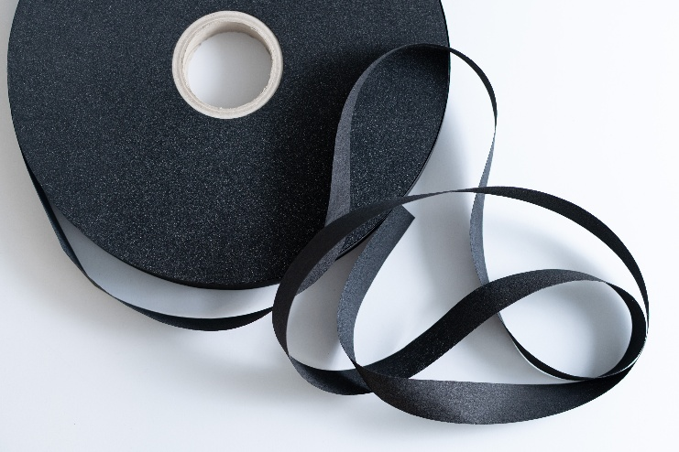
Freudenberg cable tapes.
Source: ©Freudenberg Performance Materials

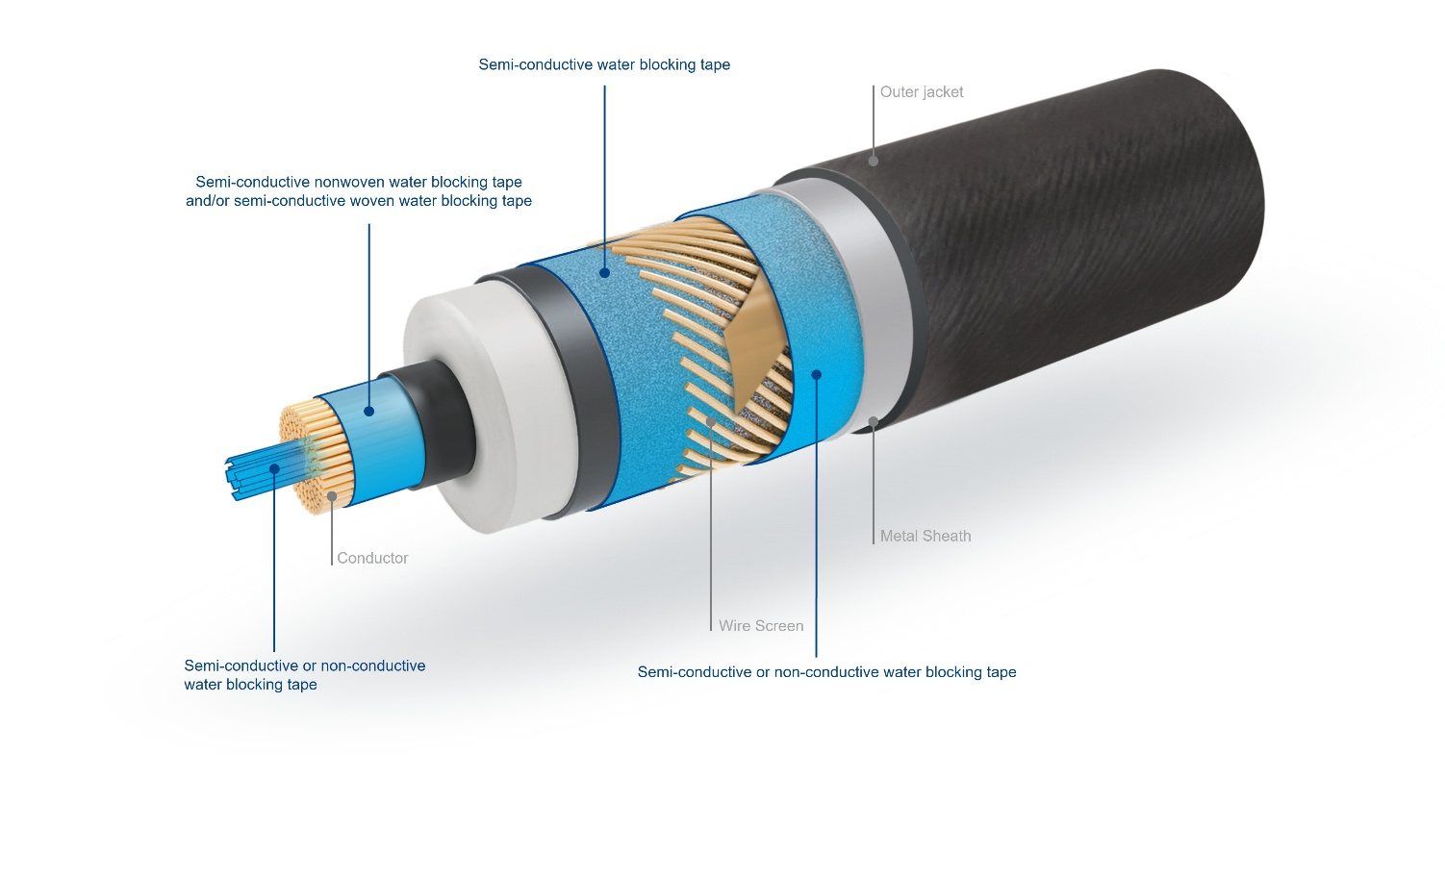
Example of applications for Freudenberg’s cable tapes in high voltage power cables.
Source: ©Freudenberg Performance Materials

Contact for media inquiries
Freudenberg Performance Materials Holding GmbH
Katrin Böttcher  Manager Global Media Relations  Höhnerweg 2-4 / 69469 Weinheim / Germany  Tel. +49 6201 7107 014  Katrin.Boettcher@freudenberg-pm.com  www.freudenberg-pm.com | Annalena Wahlig  Specialist Marketing & Communications  Höhnerweg 2-4 / 69469 Weinheim / Germany  Tel. +49 6201 7107 405  Annalena.Wahlig@freudenberg-pm.com  www.freudenberg-pm.com
About Freudenberg Performance Materials
Freudenberg Performance Materials is a leading global supplier of innovative technical textiles for a broad range of markets and applications such as apparel & shoe, building, civil engineering, energy, filtermedia, healthcare, household & living, industrial & manufacturing, mobility & transport, as well as coated technical textiles. In 2024, the company generated sales of more than €1.4 billion, operated 35 production sites in 14 countries around the world and had around 5.000 employees. Freudenberg Performance Materials attaches great importance to social and ecological responsibility as the basis for its business success. For more information, please visit www.freudenberg-pm.com

In 2024, the Freudenberg Group employed more than 52,000 people in around 60 countries worldwide and generated sales of some €11,9 billion. For more information, please visit www.freudenberg.com

