PRESS RELEASE

Techtextil 2026:
Freudenberg Performance Materials presents MehlerHeytex and Filc
Weinheim, February 26, 2026 – Freudenberg Performance Materials will showcase textile innovations that increase efficiency, performance and sustainability in industry and mobility at Techtextil 2026. For the first time since the merger of Mehler Texnologies and Heytex, the MehlerHeytex brand will make its debut as a leading expert in coated technical textiles. Moreover, Freudenberg Performance Materials Filc (Filc), specialist for advanced needlepunch nonwovens and laminated materials, will present its groundbreaking solutions for automotive applications. Filc customers can benefit from the perfect combination of functionality, comfort and sustainability. The Freudenberg Performance Materials experts are looking forward to welcoming visitors to the trade fair at Stand A11 in Hall 11.0 from April 21 – 24, 2026.
MehlerHeytex: more technology, more markets, more customer centricity
Under the motto “Engineered solutions that move the world”, MehlerHeytex will introduce itself as the optimal partner, for example in the development of special solutions. MehlerHeytex offers one of the most comprehensive technology platforms on the market and serves a wide spectrum of international industries. Following the merger, Mehler Texnologies and Heytex have joinied forces, combining now their know-how and offering broader expertise and greater customer centricity worldwide. Customers also enjoy the benefits of sales offices in an even larger number of countries – with contacts fluent in the national languages and short communication channels.
Filc: high-performance nonwoven solutions for modern mobility
Freudenberg Performance Materials Filc (Filc) provides visitors with in-depth insights into its innovative nonwoven solutions for the automotive sector. These include efficient acoustic materials, nonwovens for seatings and for luggage compartments.

With Finsol, Filc provides lightweight acoustic nonwovens that absorb sound, effectively reduce noise and improve comfort in vehicles. The materials support multiple automotive applications, including door panels, trunk liners, headliners, wheel-arch liners and many more. Their lightweight construction contributes to improved EV efficiency and range. They are available in 100% polyester versions or with recycled content.
For complex seat designs, Filc offers low-emission, low-flammability and shape-stable nonwovens. They improve comfort and climate control, and simplify manufacturing and assembly processes. Certain materials, such as FilFlex, are optionally made from 100% PET, thus providing recyclability.
Filc has developed durable, abrasion-free, lightweight nonwovens designed for luggage compartment linings. These materials even perform in extreme environmental conditions and are fully recyclable. They provide broad design options – from custom colors and flexible embossing to easy-clean treatments.
Fotos:
Source of all photos: ©Freudenberg Performance Materials
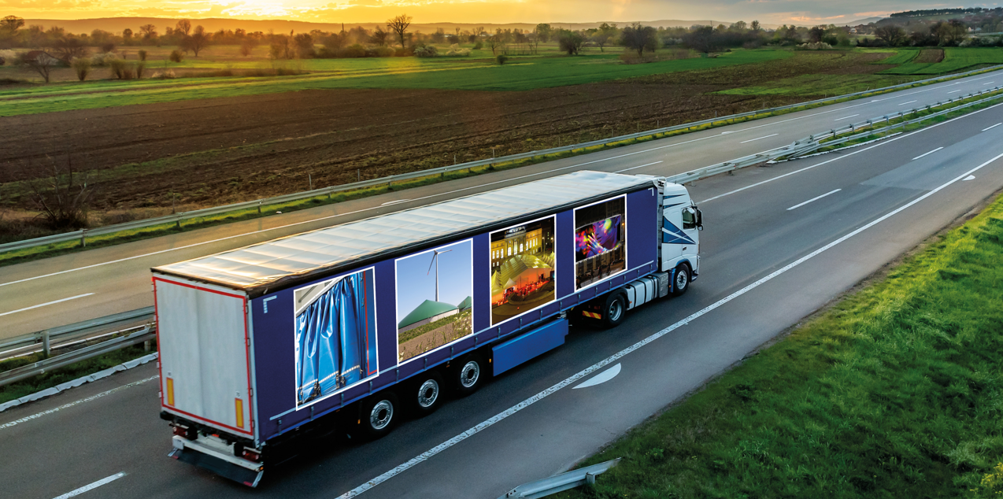
MehlerHeytex offers one of the most comprehensive technology platforms on the market and sales offices in a larger number of countries.
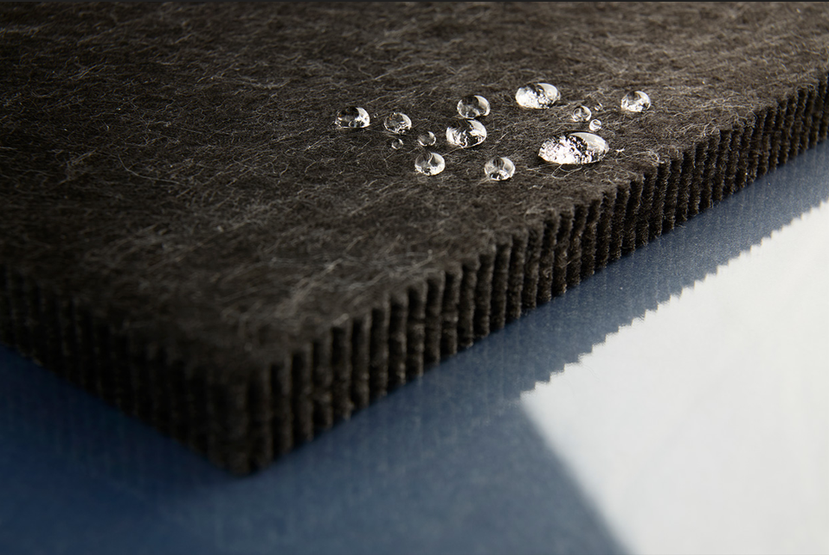
Finsol: lightweight acoustic nonwovens, effectively reducing noise and improving comfort in vehicles.
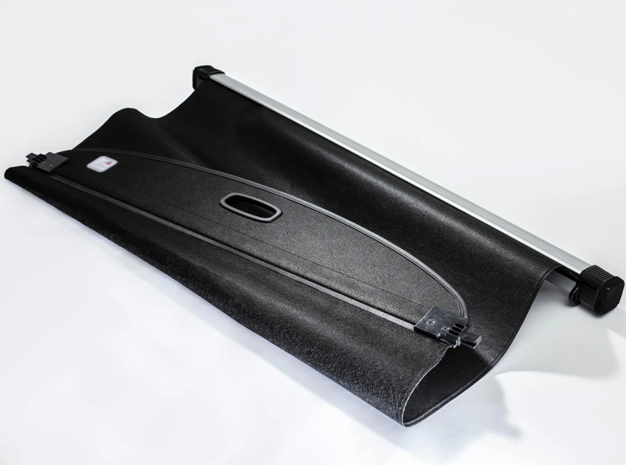
Perform in extreme environmental conditions and are fully recyclable: luggage compartment linings from Freudenberg Performance Materials Filc.

Contacts for media inquiries
Freudenberg Performance Materials Holding GmbH
Katrin Böttcher  Manager Global Media Relations  Höhnerweg 2-4 / 69469 Weinheim /Germany  Phone +49 6201 7107 014  Katrin.Boettcher@freudenberg-pm.com  www.freudenberg-pm.com | Annalena Wahlig  Specialist Marketing & Communications  Höhnerweg 2-4 / 69469 Weinheim / Germany  Phone +49 6201 7107 405  Annalena.Wahlig@freudenberg-pm.com  www.freudenberg-pm.com

About Freudenberg Performance Materials
Freudenberg Performance Materials is a leading global supplier of innovative technical textiles for a broad range of markets and applications such as apparel & shoe, building, civil engineering, energy, filtermedia, healthcare, household & living, industrial & manufacturing, mobility & transport, as well as coated technical textiles. In 2024, the company generated sales of more than €1.4 billion, operated 35 production sites in 14 countries around the world and had around 5,000 employees. Freudenberg Performance Materials attaches great importance to social and ecological responsibility as the basis for its business success. For more information, please visit www.freudenberg-pm.com

